Usability Evaluation: Leafy Plant-Care App
Oct 14, 2026 · @Joshua

Overview
Leafy's six mobile screens are visually clean, but four problems break the flow or the user's trust, and five more cause friction. Leafy is a plant-care app that reminds people when to water, mist and fertilize. This review covers the high-fidelity mockups in Figma: Onboarding, Log in, Home, Plant detail, Add a plant and Care schedule.
Method: a heuristic evaluation of the static screens against Nielsen's usability heuristics and common mobile conventions (touch targets, contrast, feedback, navigation). Each issue is ranked by how badly it affects the user's task and comes with a proposed fix.

What works well
The visual system is consistent and every screen has one obvious primary action.
- Clear hierarchy on Home: the urgent task sits on top, then filters, then plant cards.
- Predictable navigation: a four-item tab bar with a clearly highlighted active tab.
- Thumb-friendly actions: on Plant detail the main buttons sit at the bottom of the screen.
- Readable structure: care facts are grouped into small tiles, then a short schedule card.

Usability issues and fixes
Four issues are high severity because they stop a task or make the app look unreliable.
# | Severity | Screen | Issue | Proposed fix
1 | High | Add a plant | Dead end: a plant is selected but there is no "Add" button and no back or close. The screen sits under the Plants tab, so it is unclear how a user arrives. | Add a sticky "Add Boston Fern" button on selection and a close button. Add an "Add plant" entry on Home and the Plants tab.
2 | High | Home | The banner says "3 plants need water" but only one card is due today; the others read "tomorrow" and "in 5 days". | Count only plants due or overdue. Label the button with its scope, for example "Start watering (1)".
3 | High | Plant detail | Dates conflict: "every 7 days", "last watered 3 days ago" and "next watering tomorrow" cannot all be true. | Correct the sample data and show how the next date is worked out.
4 | High | Onboarding, tab bar | Onboarding promises growth tracking, but no screen tracks growth. "Get started" has no sign-up screen, and the Profile tab is not designed. | Design sign-up and Profile. Add a growth log (photos over time) or reword the promise.
5 | Medium | Home | Urgency colours are inverted: "Water today" is pale green while "Water tomorrow" is amber. | Use amber or red for due and overdue, neutral for later. Keep the text label so colour is not the only signal.
6 | Medium | Add a plant | The water-drop icon marks difficulty badges ("Beginner friendly", "Needs attention"), so it reads as watering status. | Use a different icon for difficulty and drop "Needs attention" from the library.
7 | Medium | Care schedule | A "Tomorrow" task sits under "Today". Every task uses the same drop icon. Days with tasks are not marked, and the "+" button does not say what it adds. | Group by Today and Tomorrow, give each task type an icon, add dots under days with tasks, and label the button "Add task".
8 | Medium | Log in | No show-password toggle, no error or validation states, a small "Create an account" link, and a Google button without the Google logo. | Add the toggle, inline errors, a more prominent sign-up link and the logo.
9 | Medium | Plant detail | The three stat tiles look tappable but are not. "Mark as watered" gives no confirmation or undo, and other actions hide behind "...". | Make tiles tappable or flatten them. Show a "Watered. Undo" toast and update "Next watering" immediately.
10 | Low | All | Grey secondary text on the pale green background and 11 to 12 px labels look likely to miss 4.5:1 contrast. The checkbox, chips and back button may be under 44 pt. | Measure contrast and target sizes, then raise text size and tap areas to meet WCAG AA.
11 | Low | Add a plant | Staghorn Fern uses a sprout icon that does not match the plant. | Use an image that matches each plant.

User flow and navigation
The mockups chain the six screens in one line, but real use is a hub: after login, Home leads to everything else, and three destinations are missing or have no way in.
The onboarding and login path is clear. After that, Home should be the centre. Plant detail opens from a plant card, Care schedule from the tab bar, and Add a plant from Home or the Plants tab. Showing Add a plant after Plant detail in the flow hides that it has no entry point today.
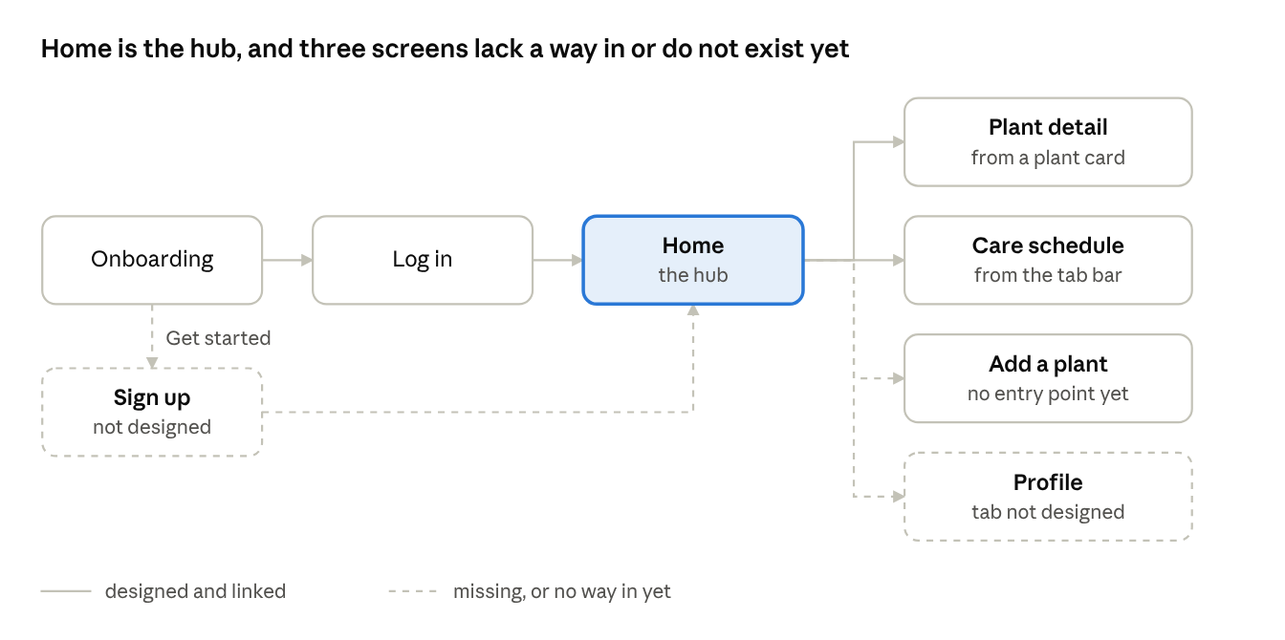
navigation map · 8 screens, 3 missing links
Dashed lines mark links or screens that the mockups do not yet provide.

Recommended priorities
Fix the four high-severity issues first, because they decide whether the core flow works at all.
- Complete the add-a-plant flow (issue 1): add the Add button, a close button and entry points from Home and Plants.
- Make the numbers agree (issues 2 and 3): one rule for what counts as due, and consistent sample dates.
- Close the onboarding gaps (issue 4): design Sign up and Profile, and either build growth tracking or reword the promise.
- Clarify status and feedback (issues 5, 7 and 9): urgency colours, task grouping and icons, and a watered confirmation with undo.
- Polish login and accessibility (issues 6, 8, 10 and 11): show-password toggle, error states, contrast and tap-target checks.

Limitations
This is an expert review of static mockups, not a test with real users, so severity ratings are judgments.
- Contrast ratios and tap-target sizes were judged by eye, not measured.
- Interactions such as transitions, animation and keyboard behaviour could not be assessed.
- Task success, time on task and error rates need a moderated test with five or more plant owners to confirm the fixes.

